**West End London**

The original Landon still perseveres after over 50 years, although it has since had a facelift to improve infrastructure. The West End neighborhood has something for everyone - from theater to dining to historic sights. That said, the West End Landon is far from being solely a tourist’s hotel. The community doesn’t just ebb and flow around the hotel - the community pours into the hotel, making The Landon an important venue for community activities and meetings. And the not-to-miss Rooftop Cafe is a great place for travelers and locals to engage over drinks, food, and good conversation.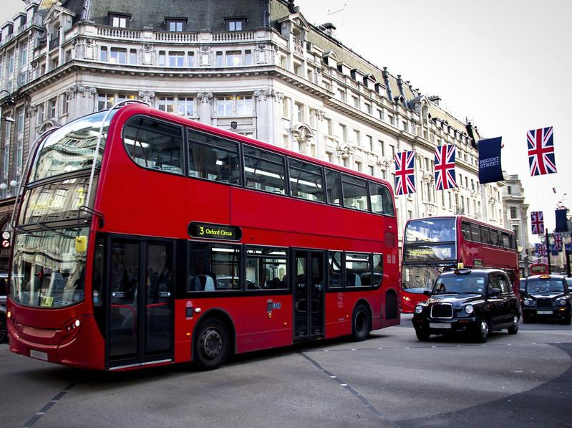

## Event Information

### Business Meetings

The West End Landon was recently rated in the top 10 hotels for business travelers in London, in a survey conducted by Lowell Travel Magazine. The study considered such variables as location, size, technology, dining, staff, and accommodations, and we received high marks in every category, with highest marks in both dining and technology, beating out all our competitors.

### Weddings and Social Events

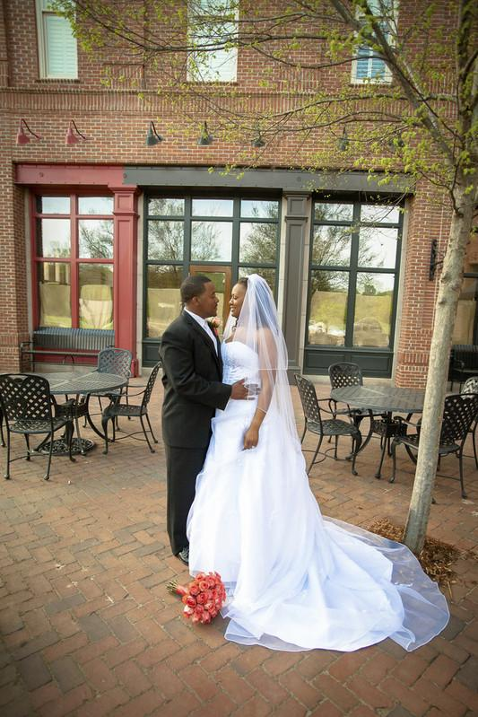Weddings, bar mitzvahs, family and class reunions, and so many other events are some of the most memorable times in our lives. When you entrust us to handle your wedding, or other event, you’re putting your faith in our professional reputation – and that’s not a responsibility we take lightly. We work hard to make your event dreams come true, aligning all our resources, including wedding planners, caterers, master chefs, florists, designers, and so much more.

Whether you’re planning a small, intimate ceremony, traditional wedding, or an extravagant gathering, we can tailor a custom package that will be perfect for your special day. Our event and wedding planners have built outstanding relationships with local businesses in our community and are here to help with every aspect of planning for your celebration. We are dedicated to creating a unique experience that you will cherish for a lifetime. Here’s just some of what we can offer for your special event:

## Services Available:

* Event and wedding planners
* Floral and table arrangements
* Bridal/groom suites
* Indoor dance floor
* On site photographer
* Catering services
* Bar services

## Local Attractions

Whether you’re a theater enthusiast, enjoy epic shopping, or love to stroll and people watch, you’ll find London’s West End has an endless opportunity to partake in all these activities. The West End is the heart of London’s “Theaterland” and offers the best in drama, comedy, and musical productions. There are over 40 theaters in the West End, and staying at the West End Landon will put you front and center to them all.

When not attending a show, you can wander through miles and miles of the best shopping in the world, including Oxford, Regent, and Bond Streets. Feast your eyes on the endless choices of global brands and locally-sourced goods that abound in the upscale department stores, hip boutiques, and unique crafter stalls in the West End.

Then, at the end of the day, treat yourself to a relaxing and luxurious evening at the

West End Landon. Enjoy a five-star meal, overlooking the city, at the Landon Rooftop Cafe, followed by a soak in your room’s private Jacuzzi tub. Then top off the day with a comfortable and restful slumber that will have you ready for another day of exploring the many sites around the West End.

|  |  |
| --- | --- |
|  | |
| **1.** | Save the file as *“My Challenge”* in the Chapter 2 Exercises folder. |
| **2.** | Apply the *Gallery* Theme to the document. |
| **3.** | Apply a 3-D page border with default line width to the entire document, Purple, Accent 4, Darker 25%. |
| **4.** | Apply the **Basic (Simple)** Style Set to the document. |
| **5.** | Apply the **Austin Header style.** Do not display the header on Page 1. |
| **6.** | Add the following properties to the document:   1. Title: “***West End London Location***” 2. Comments: “***Final***” 3. Category: “***New Locations***” 4. Subject: “***Events***” |
| **7.** | Set the Page Color to ***Purple, Accent 4, Lighter 80%.*** |
| **8.** | Configure the document to use ***Moderate*** margins. |
| **9.** | Add the following alt text to the photo on page 1: “***Double-Decker Bus in London”***. |
| **10.** | Using Inspection Tools, remove any hidden text, watermarks or comments from the document. |
| **11.** | Check the document for accessibility issues. Resolve the missing Alt Text issue with image02.jpg by typing the following: “***Weddings and Receptions***”. |
| **12.** | Save pages 1-3 of the document as a PDF file in the Chapter 2 file with the default name. Do not open the document after publishing. |
| **13.** | Save and Close the file. |